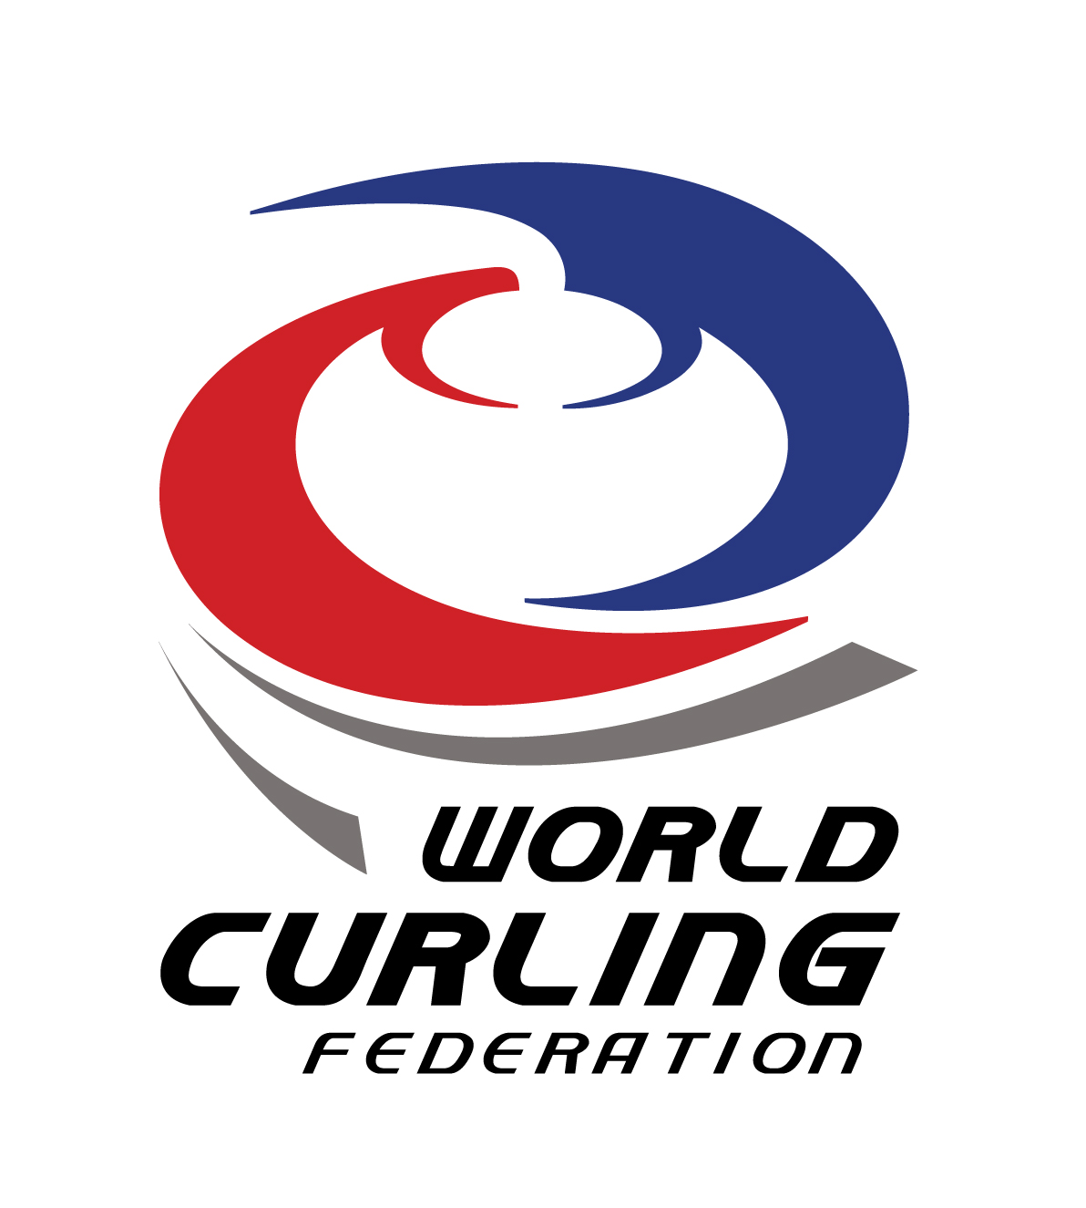

WCF ELITE COACH SYMPOSIUM
ÖSTERSUND, SWEDEN
14 – 16 AUGUST 2015

The WCF is pleased to announce an Elite Coach Symposium to be held in Sweden in August. Member Associations wishing to participate are requested to nominate one high performance coach from their Association who they feel will benefit from interacting with and sharing information with other top coaches from around the world. Please note that this is not a training course for beginner coaches, but is only for those coaches with extensive international coaching experience. Keith Wendorf and the WCF Competitions and Development team will be facilitating the symposium.

Location: Clarion Grand Hotel, Östersund, Sweden

Goal of the Symposium: Elite coaches are passionate about curling, and they know that high performance curling impacts grassroots curling development. The group will discuss how to minimize any negative side effects, such as breaking up teams by a selection process, focusing only on top performers, etc. Ideas and methods on how to become a better coach, proposals for how to improve WCF championships, as well as any issues that coaches face can also be discussed. Input from the participants of any relevant topics they would like on the agenda is welcome.

Cost: Participants are responsible for their own travel and accommodation costs. Lunch (Friday, Saturday and Sunday), and supper (Friday and Saturday) will be provided by the WCF or the hosts. Other costs are the responsibility of the individual.

Participants: Member Associations may nominate one high performance coach from their Association. A second participant may be nominated but will only be considered if space is available. Selection of the coaches will be done by the WCF. A brief coaching resumé is required. Deadline for nominations is 01 June 2015.

Language: The symposium will be conducted in English and all participants should be able to converse and share ideas in that language.

WCF ELITE COACH SYMPOSIUM
ÖSTERSUND, SWEDEN
14 – 16 AUGUST 2015

Proposed Schedule

Thursday, August 13 Arrival at Åre/Östersund Airport
Check in at your hotel

Friday, August 14 09:00 Start of the Symposium
12:00 Lunch at Arctura hosted by Peak Innovation
13:30 – 14:30 visit National Winter Sport Research Centre (walk back to hotel, 10 – 15 minutes)
15:00 Symposium
18:00 Dinner at City Hall (hosted by the Östersund municipality – 5 minute walk from hotel)

Saturday, August 15 09:00 Symposium
12:00 Lunch at the hotel
13:00 Symposium
Dinner at Verkö Castle http://www.sirwinston.se/verkoslott.html

Sunday, August 16 09:00 Symposium
12:00 Lunch at the hotel
Departure

REGISTRATION FORM

Member Association (MA): ________________________________________

Position in MA (person submitting form): _____________________________

Coach Nominated: ______________________________________________

A resumé listing coaching experience must accompany this registration form and should be sent to keith.wendorf@worldcurling.org

Deadline for Registration: 01 June 2015

Successful applicants will be notified as soon as possible, by 08 June at the latest.

Flights: (notice that the flight schedules may change)

STH-OSD (Stockholm – Ostersund)
Monday 08.20, 11.25, 18.00
Tuesday 08.20, 18.00
Wednesday 08.15, 18.00
Thursday 08.20, 11.15, 18.00
Friday 08.20, 11.15, 18.25
Saturday 13.00
Sunday 11.15, 15.20, 18.30

OSD-STH (Ostersund – Stockholm)
Monday 09.45, 12.40, 19.25
Tuesday 09.45, 19.25
Wednesday 09.40, 19,25
Thursday 09.45, 12.40, 19.25
Friday 09.45, 12.40, 19.50
Saturday 14.20
Sunday 12.35, 16.40, 19.55

Recommended Hotels: (your choice, meetings are at the Clarion Grand)

Clarion Grand Hotel in the centre of Östersund https://www.nordicchoicehotels.com/clarion/clarion-hotel-grand-ostersund/?_ga=1.98533727.1924241358.1415822604
Single room: 1050 SEK/night and person (approx. Euro 110)
A taxi from the airport should cost about 300 SEK (approx. Euro 33)

NOTE: The Swedish Curling Association has reserved some single rooms at the Clarion (arrival 13 August & departure 16 August). Please book your room there through Peja Lindholm: peja.lindholm@curling.se
Note: Cancellations must be received 14 days prior to arrival or there will be a penalty.

Frösö Park, newly built hotel nearby the airport
http://frosoparkhotel.se
Single room: 1290 SEK/night and person (approx. Euro 135)

Note: Exchange rate from xe.com on 17/2/2015 (1 euro = 9.53 SEK)

KW – Elite Symposium – 03 March 2015

